IST 363

Lab 01

This Lab Covers
- Warmup and review for HTML and CSS

warmup
The answers to these questions will go in the answer template on Blackboard. You may not use AI to answer the questions in this section.
As a review, below are the required HTML tags with descriptions. When VS Code puts in the required tags, it adds a meta tag to help with zoom on responsive design.
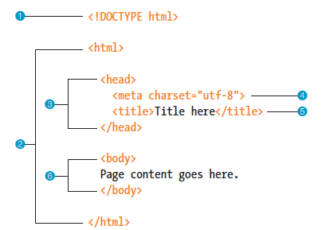
Decoding the above HTML
- version of HTML you are using
- entire HTML document should be contained in this element
- info about your html page that will not display in main browser window
- character encoding for your document.
- Title that appears at the top of your browser window
- All the content goes here
- How do you get the HTML below to appear in your editor without typing all of it?
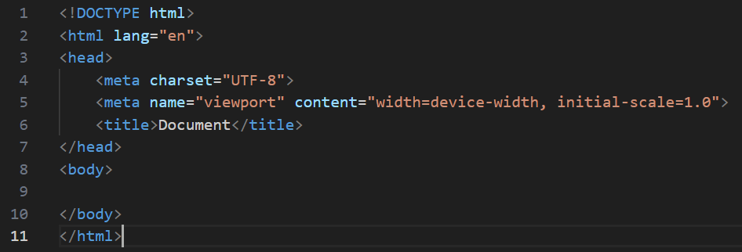

Codepen.io is an online tool for testing and sharing HTML/CSS/JavaScript. We’re going to use it this semester in lectures and labs. There’s no need for the required HTML page tags you see above in Codepen.io. For the following questions we will be using code you can find here: https://codepen.io/Laurie-F/pen/azoYrEG
The questions below are all about selectors. If you are shaky on selectors go to Blackboard and do this week’s reading first.
- Write one CSS rule that makes the following change. You may not change the HTML.
Original | Change
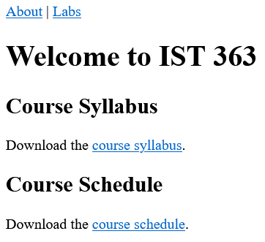 | 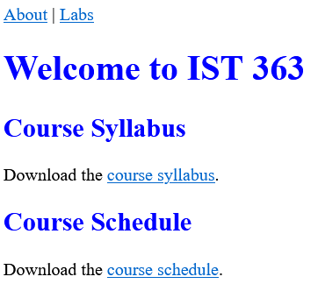

- Write one CSS rule that makes the following change. You may not change the HTML.
Original | Change
 | 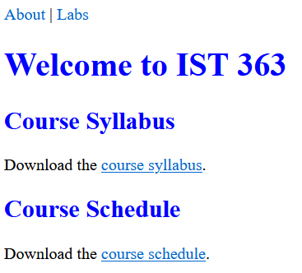

- Write one CSS rule to change the background color of the About and Labs links when a mouse moves over the link. Don’t change any of the other links on the page.
Original | Change
 | 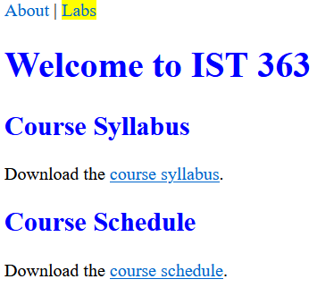

- Write one CSS rule that makes the following change. You may not change the HTML. Use any sans serif font.
Original | Change
 | 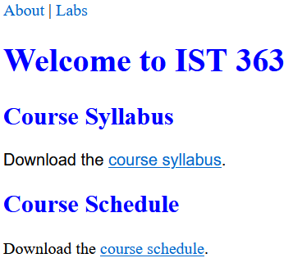

review Page
In this section, you will create your own version of the web page demoed at the beginning of the lab. For reference, there’s a screenshot below. Here are the things you should consider when you make this page.
- Put in your required page tags and add your content with no CSS first. The paragraph is your 3 Ps from the icebreaker at our first class. The pictures should be one photo of you and one photo to illustrate each of your 3 Ps.
- Use the same colors as me:
Orange - E38E49
Light Blue - D4EBF8
Dark Blue - 0A3981
- Images – you will probably need to resize and or crop images for this page. There’s a cool tool offered online by Adobe
- The sizing of things like text and the whitespace doesn’t have to be perfect but try to get it generally the same as my page. Pay attention to details like rounded corners.
- You will need containers. This containers refresher page
- Use flexbox to display the 4 images. If you’re shaky on flexbox, do the reading linked in Blackboard before you do this part.
- This design is centered on the page. Try to do it without looking, but if you need a hint, this guide gives good info about centering
- This webpage is responsive (looks good on mobile devices). Try to do it without looking, but if you need a hint, try this webpage
- Check your page. Is anything messy? Clean it up. The name, paragraph, and images should line up nicely. The images should not be different sizes that are either stretched or don’t line up nicely.
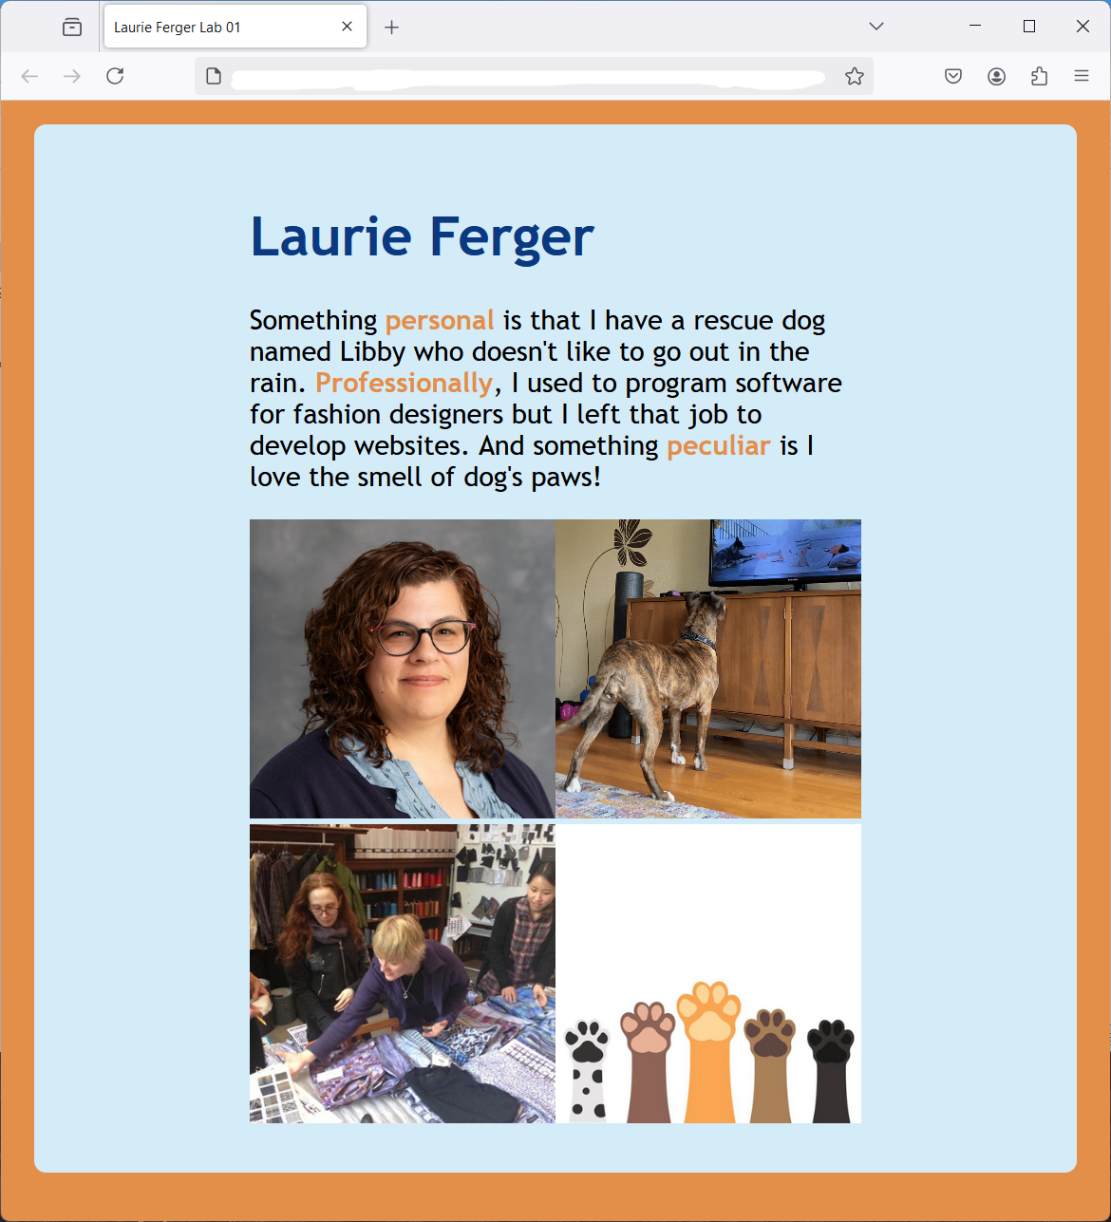

What to hand in
- For the review questions, paste your answers into the template provided in Blackboard.
- For the review page, hand in the URL. Note that if your URL doesn’t work for me, you will get a zero on this part. Check and make sure github.io is part of the URL in the address bar. If it’s not, you haven’t given me the correct link.

